**WEEK-06 HANDS-ON**

**TOPIC-REACT**

**CODE-1:**

Create a new React Application with the name “myfirstreact”, Run the application to print “welcome to the first session of React” as heading of that page.

**SOURCE CODE:**

**OUTPUT:**

**CODE-2:**

**Create a react app for Student Management Portal named StudentApp and create a component named Home which will display the Message “Welcome to the Home page of Student Management Portal”. Create another component named About and display the Message “Welcome to the About page of the Student Management Portal”. Create a third component named Contact and display the Message “Welcome to the Contact page of the Student Management Portal”. Call all the three components.**

**Source code:**

**Output:**

**CODE-3:**

**Create a react app for Student Management Portal named scorecalculatorapp and create a function component named “CalculateScore” which will accept Name, School, Total and goal in order to calculate the average score of a student and display the same.**

**Source code:**

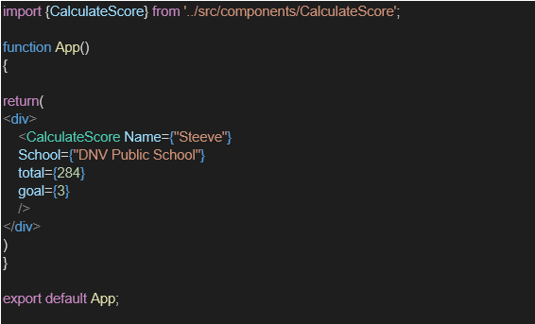

**Output:**

**CODE-4:**

1. **Create a new react application using *create-react-app* tool with the name as “blogapp”**

**Source code:**

import React from 'react';

class Posts extends React.Component {

constructor(props) {

super(props);

// Initialization code

}

loadPosts() {

// Code to load posts

}

componentDidMount() {

// Code that runs after component mounts

}

render() {

// Rendering code

return (

<div>

{/* JSX content */}

</div>

);

}

componentDidCatch(error, info) {

// Error handling code

}

}

export default Posts;

**OUTPUT:**

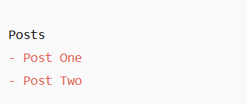

**CODE-5:**

**My Academy team at Cognizant want to create a dashboard containing the details of ongoing and completed cohorts. A react application is created which displays the detail of the cohorts using react component. You are assigned the task of styling these react components.**

**CohortDetails.js**

import React from 'react';

import styles from './CohortDetails.module.css';

const CohortDetails = ({ cohort }) => {

// Determine color based on status

const headingStyle = {

color: cohort.status === 'ongoing' ? 'green' : 'blue',

};

return (

<div className={styles.box}>

<h3 style={headingStyle}>{cohort.name}</h3>

<dl>

<dt>Mentor:</dt>

<dd>{cohort.mentor}</dd>

<dt>Status:</dt>

<dd>{cohort.status}</dd>

</dl>

</div>

);

};

export default CohortDetails;

**APP.JS**

import React from 'react';

import CohortDetails from './CohortDetails';

function App() {

const cohorts = [

{ name: 'React Bootcamp', mentor: 'Alice', status: 'ongoing' },

{ name: 'Angular Cohort', mentor: 'Bob', status: 'completed' },

];

return (

<div>

{cohorts.map((cohort, index) => (

<CohortDetails key={index} cohort={cohort} />

))}

</div>

);

}

export default App**;**

**OUTPUT:**

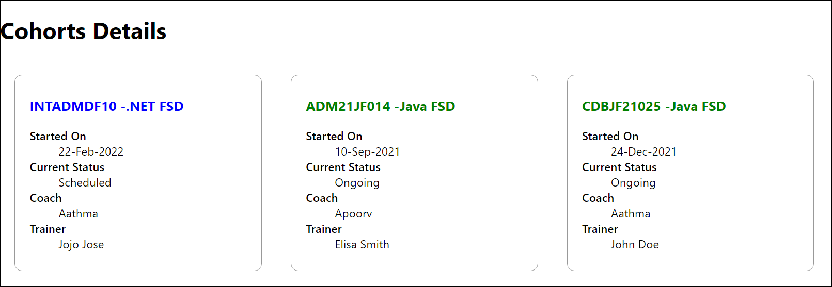

**CODE-6**

**Cognizant Academy teams want to maintain a list of trainers along with their expertise in a SPA using React as the technology. You are assigned the task of creating this React app.**

// src/App.js

import { BrowserRouter as Router, Routes, Route, Link } from 'react-router-dom';

import Home from './Home';

import TrainersList from './TrainersList';

import TrainerDetails from './TrainerDetails';

import trainers from './TrainersMock';

function App() {

return (

<Router>

<div>

<nav>

<Link to="/">Home</Link> | <Link to="/trainers">Trainers</Link>

</nav>

<hr />

<Routes>

<Route path="/" element={<Home />} />

<Route path="/trainers" element={<TrainersList trainers={trainers} />} />

<Route path="/trainer/:id" element={<TrainerDetails />} />

</Routes>

</div>

</Router>

);

}

export default App;

**OUTPUT:**

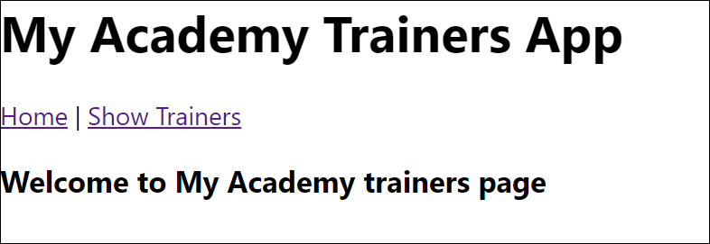

**CODE-7**

**Create a React Application named “shoppingapp” with a class component named “OnlineShopping” and “Cart”.**

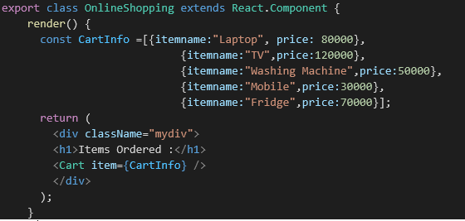

**OUTPUT:**

**CODE-8:**

**Create a React App “counterapp” which will have a component named “CountPeople” which will have 2 methods.**

**OUTPUT:**

**CODE-9:**

**Create a React Application named “cricketapp” with the following components**

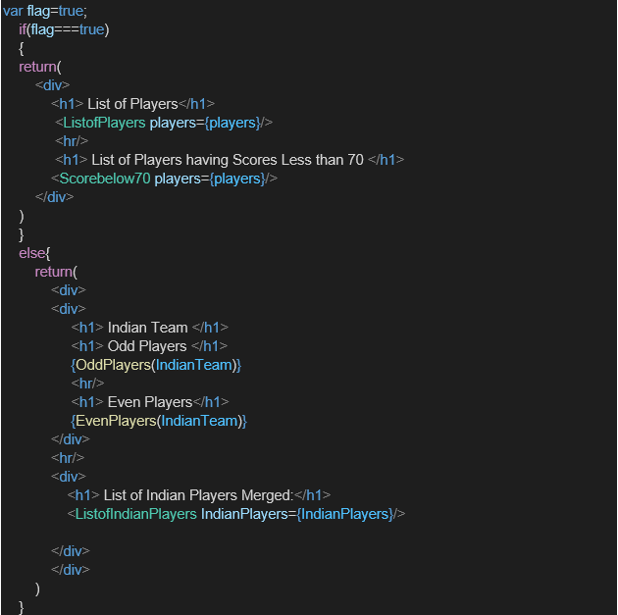

**OUTPUT:**

FLAG==TRUE

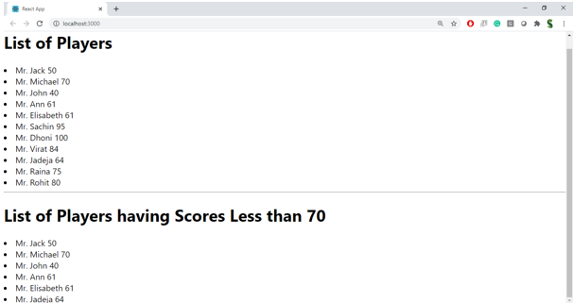

FLAG==FALSE

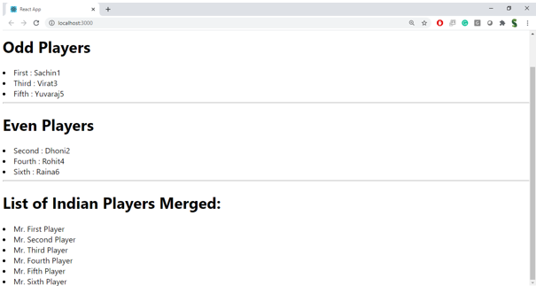

**CODE-10:**

**Create a React Application named “officespacerentalapp” which uses React JSX to create elements, attributes and renders DOM to display the page.**

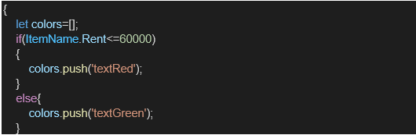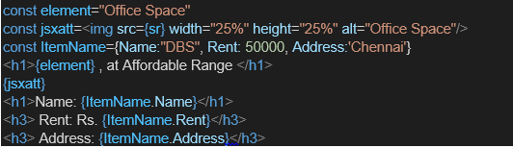

**OUTPUT:**

